* **Activity 9:**

Using the EXISTS Operator

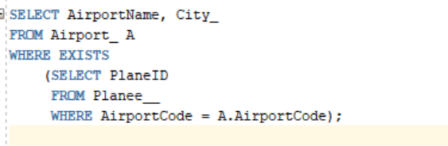

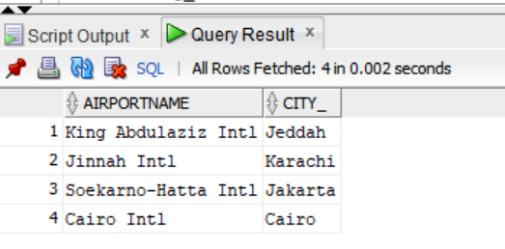

OUTPUT: